Detecting Fake vs Real News using Machine Learning



**Software Engineering Project: EEC 626**

**User Manual**

Anubhuti Dayal – 2824826

Oyindoubra Timi – 2822556

User Manual

This is user manual for the project code “Detecting Fake vs Real News using Machine Learning”.

Please follow below steps to run the program in your machine

1. Download and install PyCharm or any python supported IDE. For this project, PyCharm and VS Code were used.

You can follow this link - <https://youtu.be/qC6-Uv9m_Ls>

<https://www.jetbrains.com/pycharm/download/#section=windows>



1. Open the project folder in the PyCharm environment on your machine after installation
2. Open a terminal on the IDE
3. If jupyterlab is not already installed in your system, type “pip install notebook” and hit “Enter” on your keyboard

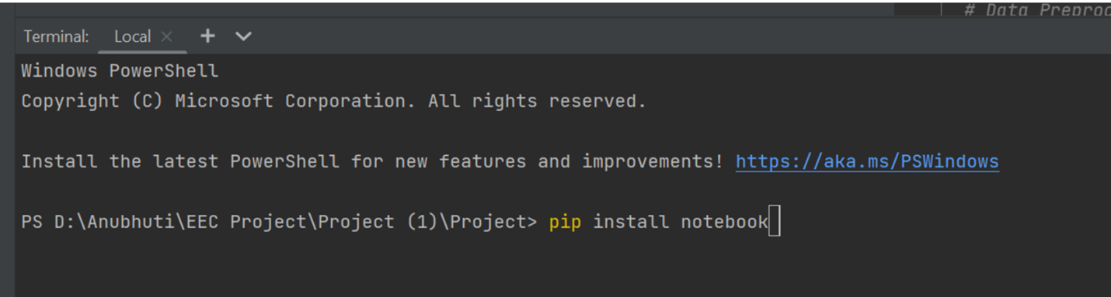

1. Next, type “jupyter notebook” and hit “Enter.” This should open a tab on your browser that shows all the documents and files in the project folder
2. Scroll to “FakeNews.ipynb" file and click on it. This should open in a new tab

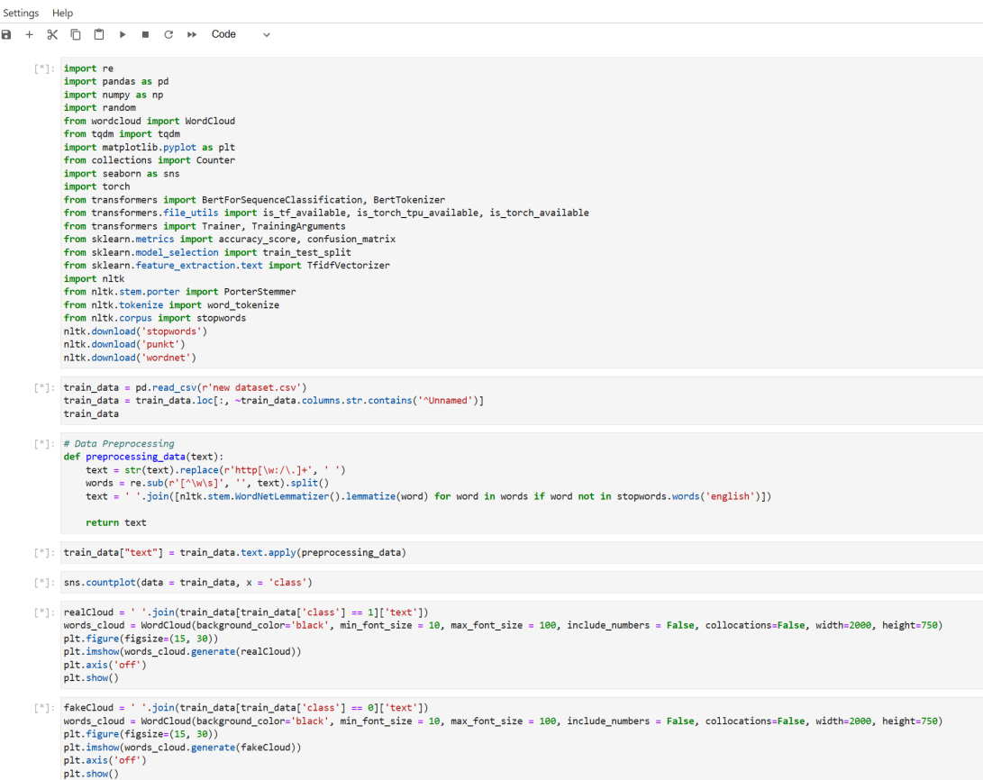

1. Run each cell. Some cells might take hours or days to finish running depending on the speed of your device
2. After running the last cell, an input box will be displayed. Input your news in the box and hit “Enter”
3. The result will be displayed to tell you if the news is real or fake

